1)

Variables Domains Binary Constrains

C1 {A, C} C1 ≠ C2

C2 {A} C2 ≠ C3

C3 {B, C} C2 ≠ C4

C4 {B, C} C3 ≠ C4

C5 {A, B}

2) Constrain Graph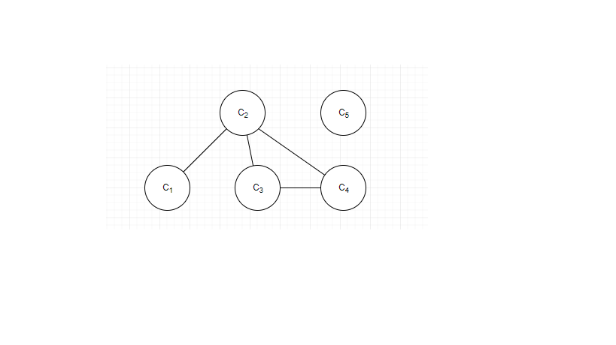

3)

Backtracking

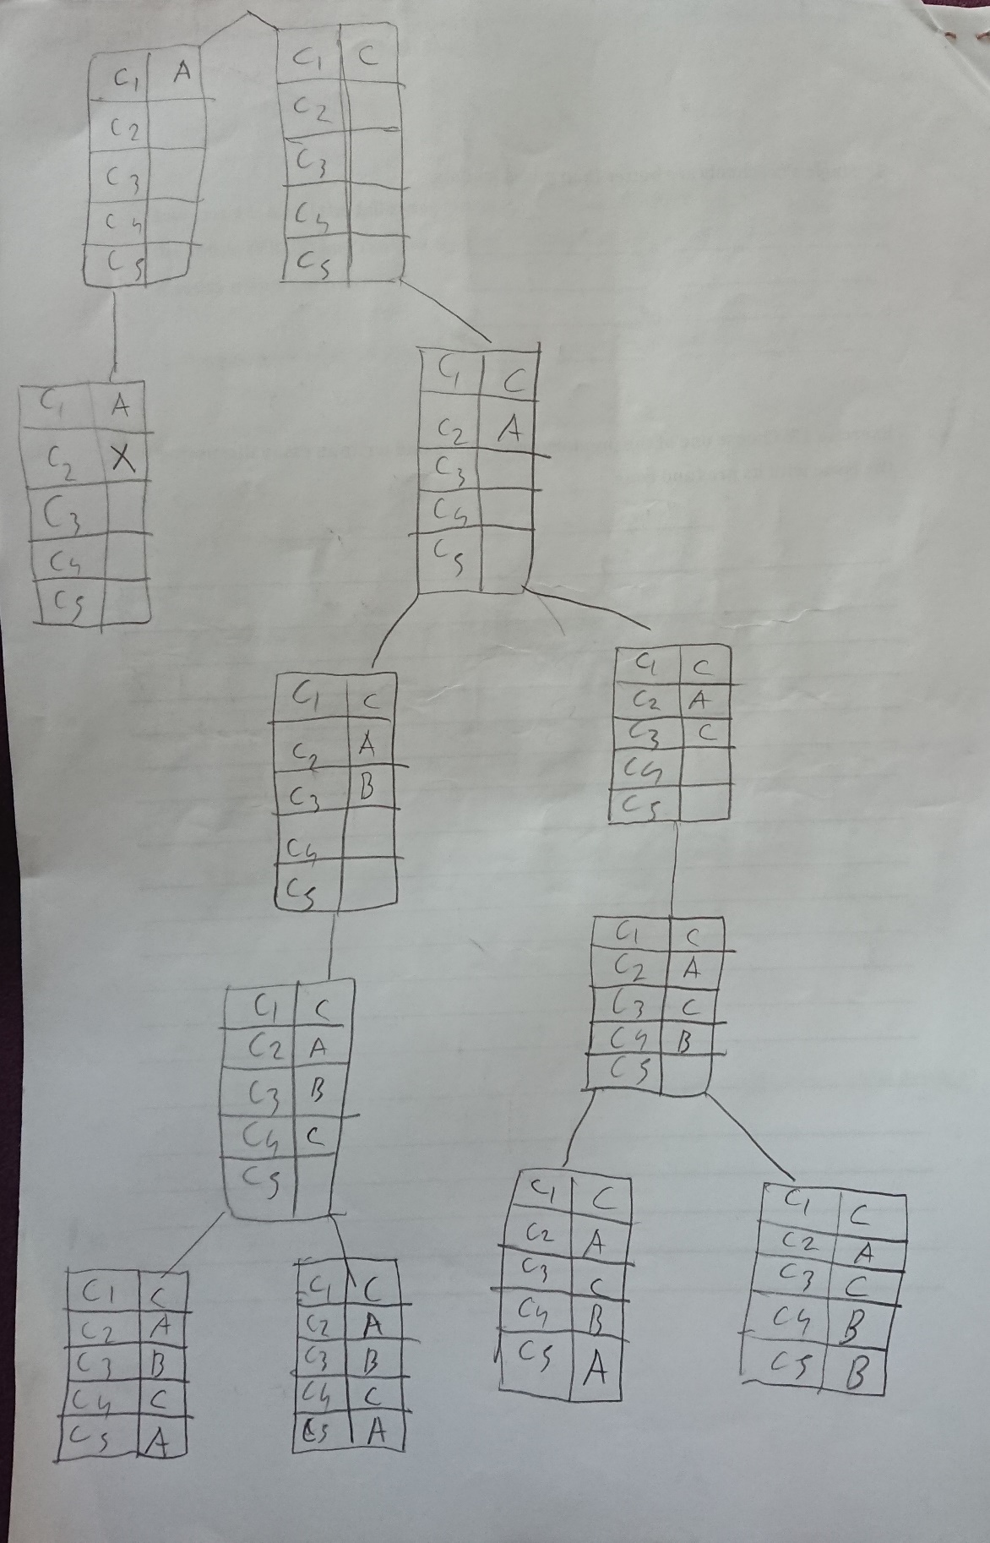

Minimum Remaining Value

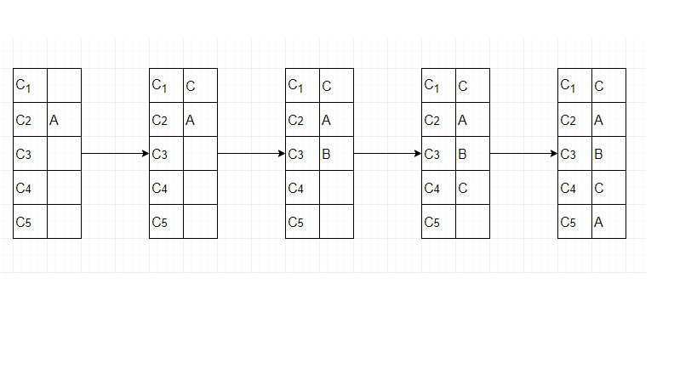

Least Constraining Value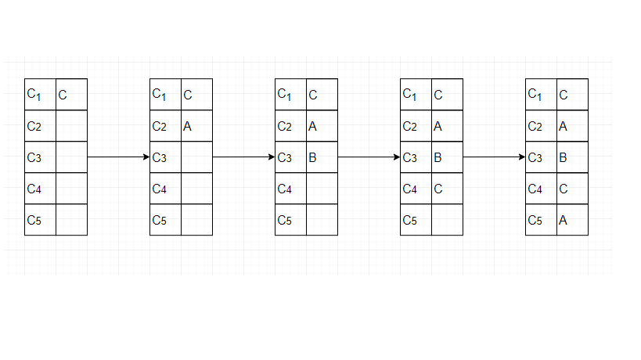

Forward Checking